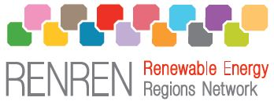

Draft
Communication Plan
RENREN – Renewable Energy Regions Network

2010-04-13
Jämtland - JiLU
Björn Nilsson


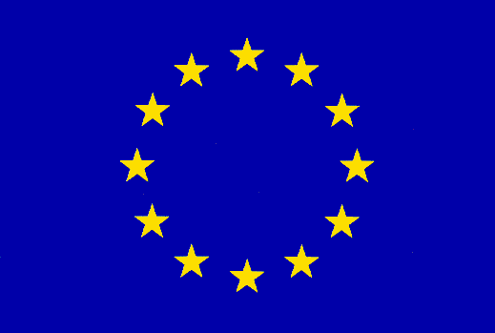

Table of Contents
1. Project background 3
1.1. Foundation and set-up 3
1.2. Objectives of RENREN 3
1.3. RENREN Partners 4
2. Objectives of the Communication Plan 5
3. RENREN communication strategy 6
3.1. Communication between partners 8
3.1.1. Partners communication responsibilities 8
3.1.2. The responsibilities by Components 8
3.2. External communication 12
3.2.1. Direct communication of the whole partnership 12
3.2.2. Communication tools 13
3.2.3. Regional and local dissemination: the partners’ task 15

Project background

Foundation and set-up
The Renewable ENergy Regions Network (RENREN) grew out of a collaboration of 6 core regions concerned to play their part in a global climate action and the security of energy supply. They were seeking to improve regional policy-making to nurture renewable energy sources (RES). They signed a Charter to this effect in April 2007. To develop an EU-wide partnership and spread the learning benefits of RENREN further, it was decided in 2008 that new members should be approached and funding sought via INTERREG IVC to optimally coordinate RENREN exchanges.

The expanded RENREN within the frame of INTERREG IVC, with 14 partners, is well-balanced geographically and regarding different levels of experience. The partners have either strong expertise and/or commitment to one or more RES. There are expert regions in wind power (Schleswig-Holstein, Navarre), solarthermal/photovoltaic (Pays de la Loire, Cyprus, Navarre), biomass (Jämtland), geothermal (Westfjords), ocean energy (Wales), and hydropower (Jämtland), as well as learning regions (Lodz, Ustí, Timis, Central Macedonia, North Hungary). All regions will benefit from the knowledge-sharing because of the breadth of the partnership and themes to be addressed. The RENREN project builds on three Working Groups (WG) based on technology families:

WG 1: Wind, ocean, hydropower;
WG 2: Geothermal, biomass;
WG 3: Solar thermal, photovoltaic.

Technology families were determined based on shared characteristics of scale, setting and end-use. Each partner takes part in WGs either as expert or learning region. Expert regions (e.g. Navarre for wind, Jämtland for biomass) have more than a decade of renewable energy sources (RES) policies. Learning regions (e.g., Lodz, Timis) are taking first steps in RES policy, but are strongly committed.

Objectives of RENREN
The overall objective of RENREN is the sustained improvement of regional policies so that frameworks to nurture the development of RES are optimized. This will pave the way for the further growth of RES in all partner regions, strengthening EU regions' positions as worldwide pioneers in this field. RENREN will thus support regions in making a full contribution to the achievement of EU 2020 RES targets.

RENREN will ultimately support EU climate change actions, also with regard to the Directive of the European Parliament and the Council on the promotion of the use of energy from renewable sources based on COM(2008)30, in particular to achieve the minimum share of 20 % RES of the total energy consumption.

Furthermore, it shall make a contribution to reducing the EU's dependency on energy imports, with the effect of triggering indigenous economic growth and creating job opportunities. This is also of key importance with regard to opening up economic avenues beyond the recent financial crisis and its impact.

To achieve these objectives, RENREN partners will exchange information on the best practices but also bottlenecks and identify policy choices to improve regional frameworks for renewable energy expansions. It will explore the enabling conditions for RES that regions can influence and how these can be fine-tuned to support different technologies, such as wind, biomass or solar.

It is important that RENREN shall be perceived as
- a leading network in Europe, adding value to diverse regional measures to nurture renewable energy sources (RES)
- a collaborative partnership and open forum, tackling together practical challenges in developing RES
- a key learning forum for policy-makers to compare regional experiences and identify transferable good practice

RENREN Partners
The project consortium includes 14 European partners. All activities are naturally carried out by people in organisations/institutions, although they are in this communication plan referred to by the region, e.g. Jämtland.

PARTNER COUNTRY REGION INSTITUTION
LP Germany Schleswig-Holstein Federal State of Schleswig-Holstein
P2 Great Britain Wales Welsh Assembly Government
P3 Sweden Jämtland County Council of Jämtland,
Institute of Rural Development
P4 Iceland Westfjords The Association of municipalities in
the Westfjords
P5 Cyprus Cyprus Cyprus Institute of Energy
P6 Spain Navarre Department of Innovation,
Enterprise and Employment of
Government of Navarre
P7 Spain Castilla y León Regional Energy Agency of Castilla
y León
P9 France Pays de la Loire Pays de la Loire region
P10 Romania Timis County The Agency for Social and
Economic
Development of Timis County
P11 Poland Lodz Lodz Region
P12 Czech Rep. Ústí Ústí Region
P13 Greece Central Macedonia Region of Central Macedonia
P14 Spain Andalusia Andalusia Energy Agency
P15 Hungary North Hungary Bay Zoltán Foundation For Applied
Research, Institute for Logistics and
Production Systems

The project partners should actively contribute as administrators of their regional governmental bodies. Experts are welcome to give their support to the project objectives by e.g. district heating companies, energy planning offices, local transportation authorities or energy advisors.

Objectives of the Communication Plan
The overall objective is to create a comprehensive network/database for distributing information related to the project implementation and results, while identifying key actors in the process of transforming energy systems of the regions involved.

Further on, the purposes of the RENREN Communication Plan are to:
- Set goals and aims for the general communication of the project
- Define how to reach the target groups. The scope of contacts with target groups should align with the application form of the project
- Describe the promotion and dissemination activities to be developed during the project life cycle to emphasise key messages and meet the objectives set by the consortium
- Describe the instruments, tools, resources and events that will be used in order to reach the communication objectives
- Ensure a good coordination between the partners in the communication and dissemination activities
- Convey the message of RENREN
- Create a framework that allows the RENREN consortium and the INTERREG IVC JTS to measure the impact and effectiveness of the project’s communication activities
- Reach a communication community in the project in order to communicate with European stakeholders

The Communication Plan is dynamic and may be updated according to new developments and needs.

RENREN communication strategy
The project needs to produce high quality material, in line with the expectations of the participants and final addresses of the project. The success of the project mainly depends on the ability of the partners to convince local communities that their transformation into a “Sustainable Energy Region” is possible.

The dissemination of RENREN should not be limited to regional governmental bodies, but should focus on spreading its results towards the regional stakeholders as well as the decision makers of the different administrative levels, through specialised communication tools, as well as direct contacts (Info Days, on-site visits, workshops, etc.). This way each partner should be committed to reach efficiency and effectiveness in communication, by using all the opportunities linked to the project’s field of action to organize dissemination activities, extend cooperation, exchange knowledge and learn from other projects, but also to communicate the project results in their own language in their region. These opportunities include trade fairs, workshops, meetings with local stakeholders, publications in local magazines and all other relevant events where the partners may participate.

RENREN will focus on a medium level of cooperation according to the INTERREG IVC programme rules. This takes account of the size of the consortium and the partners' different levels of expertise in various RES fields, ranking from learning regions such as Lodz, Timis, or Usti, to expert regions such as Navarre, the Icelandic Westfjords, Schleswig-Holstein and Cyprus.

Intensive cooperation is envisaged for the transfer of results within the partnership and within each region itself (going beyond the primary target group of regional administrations). Additional regions will be involved in the project (e.g. during workshops & conferences). Other regions that are interested in RENREN but not included in the consortium will be invited to meetings and included in newsletters and email distribution lists to establish a wider cooperation.

Additionally, RES stakeholder organisations at national and European level (such as EWEA, EREC, EGEC, Deutscher Verband Windenergie, IDAE, AVEBIOM, APECYL, FEDARENE) will be, based on existing contacts, engaged in activities on a non-profit basis.

RENREN will also endeavour to liaise with EU institutions such as the European Commission DG ENER, DG Regio, the Committee of the Regions (especially for dissemination purposes and in an advisory capacity), the European Parliament, the European Investment Bank and others such as The Nordic Council of Ministers (an intergovernmental forum for co-operation between the Nordic countries, which are partly engaged in northern Europe).

Communication and dissemination activities will focus on the key target groups and happen on different levels. European, national and regional policy makers will be addressed, including municipalities, business interest organisations, energy agencies and comparable environmental expertise centres. The consortium will try to reach beyond these groups, since the process of implementation will directly involve both decision makers and industry. The dissemination will also target the scientific community (Universities, institutes, NGOs and environmental consultancies) in another way of the striving to reach of the general public.

In order to reach specific target groups different communication and dissemination activities and material have been set:

• Politicians in partner and non-partner regions, Representatives of national governments
Activities
Common dissemination events (e.g. Kick-off conference, Closing conference)

Communication material
Mid-term brochure & final leaflet
newsletters
project website
video-clip production
press release

• EU institutions, Committee of the Regions (CoR), Members of the European Parliament (MEP), European Commission (EC), especially DG TREN, DG Regio, the European Investment Bank (EIB)

Activities
Common dissemination events, Press relations with regional and specialised press, including press conferences & press releases following workshops and other events

Communication material
Mid-term brochure & final leaflet, newsletters

• Stakeholders & experts in the field of RES (e.g. EREC, EWEA, existing clusters), research institutions, SMEs, environmental groups, NGOs

All the communication material

• Other projects & networks (e.g. Fedarene - a network of regions and energy agencies, More4NRG, the EU-funded Enterprise Europe Network (EEN))

All the communication material

• General public in partner & non-partner regions

Activities
Press relations with regional and specialised press, including press conferences & press releases following workshops and other events,

Communication material
Logo & corporate design, flyer, website, video clip production:

Each partner is responsible for providing input and for printing the common material for regional use as well as for organising additional dissemination activities, promoting RENREN at RES external events (i.e. events not organised by the partner, e.g. fairs or conferences) and of informing their regional press. Each partner may choose to translate communication material. Partners hosting a workshop will organise press conferences. Castilla y Leon will monitor and coordinate the partners' contributions.

Communication between partners
The Communication Plan defines the strategy, tasks and responsibilities, however, partners cooperation in communication activities is the key for success in dissemination of results.

Partners communication responsibilities
Partners shall be in contact to cooperate in communication activities at European level and at their own regional level. Each partner has the following communication related responsibilities:
- Cooperate with the Communication officers (Castilla y León; Puy Domínguez Pérez and Jämtland; Björn Nilsson) in communication activities, i.e., inform them about all planned communication activities and provide them with deliverables such as lists of attendees (of meetings, dissemination events), photos, copies (of press releases), presentations given at external events, etc. These deliverables shall be sent both to the communication officers and the Lead Partner on time, by the end of each reporting period at the latest.
- Keep archives on communication activities (seminars and conferences, issued press releases, etc.) and media impact in their own local areas. These archives are essential for the evaluation of the project (These archives should be kept on the RENREN web page) and shall be regularly sent to the communication officers and to the Lead Partner, by the end of each reporting period at the latest.
- Send press releases about events where RENREN is presented, so that this can be uploaded on the web, within two weeks after publication.
- Newsletter: forward their contributions for each issue and review drafts for comments and improvements
- Keep regular contact with each other
- Present RENREN in relevant regional and national events
- Translate press releases into their local language and disseminate them (see Translations)
- Respond swiftly to requests made by the Lead Partner and Communication office on communication issues and respect deadlines regarding contributions, cooperation in communication actions, etc. (website, newsletters and other material)

The responsibilities by Components
Component 1 Management and coordination

Responsible partner: Schleswig-Holstein

Schleswig-Holstein will be responsible for monitoring the process between project’s outputs and dissemination. Furthermore, Schleswig-Holstein is committed to boost the project’s international dimension and will contribute to its dissemination through specialised networks allowing for the exchange of best practices during the project implementation.

The Monitoring Group (MG) chaired by the activity coordinator (Schleswig-Holstein), will carry out the operational monitoring, evaluation and coordination and prepare information for strategic decisions to be taken by the Steering Committee (SC).

Planned results: A well managed project reaching its objectives, without serious conflict between the partners, without irregularities and with smooth reporting to the programme

Component 2 Communication and dissemination

Responsible partner: Castilla y León (leader of Component 2 & Communication Officer).

Castilla y León, is the Communication Officer and Jämtland is the Deputy Communication Officer who shall coordinate and supervise specific partners´ Component 2 activities. With the drop-out of the partner P8 (Styria) during the negotiation phase of the project, Jämtland has taken on additional responsibilities to support and complement Castilla y Leon’s activities.

Responsibilities of Castilla y León
- Collect and monitor information on all communication activities of the RENREN partnership permanently reviewing the project’s Component 2 activities and comparing the planned activities as laid down in the approved Application Form, section 3.2
- Reminding partners of their duties
- Serve as intermediate between the partnership and the public, including INTERREG IVC Programme bodies for communication & dissemination matters
- Develop or coordinate and take care of the development of all relevant communication material (except for the Communication Plan) for use by the project (e.g., flyers, logo, roll-up, newsletters, mid-term brochures, press releases) and coordinate coordination activities within the partnership except for the website and the video clip production
- Inform the Lead Partner of the overall progress of communication activities and communicate any deviation from the project timetable with regard to Component 2 activities
- For all above mentioned tasks, Castilla y Leon shall closely cooperate with the Lead Partner and align its activities with the Lead Partner. For all emailing with external parties, Castilla y Leon shall copy to the Lead Partner and the deputy communication officer
- Carrying out a regional dissemination event between January and June 2011

Note: Wales has developed the RENREN logo and designed the RENREN invitations and the Roll-up on a voluntary basis and therefore laid the basis for a corporate design. Communication materials shall comply with the corporate design. All RENREN partners shall make use of the templates developed or approved by the communication officer and the Lead Partner, for instance when giving presentations to promote RENREN.

Deputy Communication Officer: Jämtland

Specific responsibilities for Jämtland:
- Develop a Communication plan
- Set up host and manage a project website
- Upload input from the partners, on the website, that can be used for communication & dissemination purposes
- Organisation of the closing conference in cooperation with Lead Partner
- Two additional dissemination events in Brussels (in cooperation with LP)
- Other events attended to promote RENREN
- Support Communication officer Castilla y León in setting up roll-up, flyer, newsletter etc.
- In cooperation with Schleswig-Holstein support the creation of the video clip production as laid down in section 3.2 of the approved RENREN Application form, to be finalised by December 2010. Specific parts: contracting, contact with the University of Applied Science in Schleswig-Holstein, collecting input from partners
- Developing a strategy for an approach of EU institutions, contact with EU stakeholders (in cooperation with the Lead Partner)

Component 3 Exchange of experiences dedicated to the identification and analysis of good practices

Responsible partner: Schleswig-Holstein

Planned results: Increased capacity of at least 40 partner region's public authorities' staff directly involved in project activities and of 90 indirectly involved staff members. 15 good practices successfully transferred

Exchange of experiences
RENREN's approach is interregional to capitalise on existing know-how and best practices and improve regional policies on renewable energy sources (RES). RENREN will involve key regional authority staff with different levels of expertise, which will mutually benefit from an exchange of experience, enhancing the evidence-base for domestic policies.

On-site visits of projects will help partners to assess their practicability as best practice examples. The activity of the WGs (technology families) will be structured around 4 sets of framework conditions ("topics") that equally apply to all RES projects;

1. Strategic Planning for RES at regional level
2. Permits & compliance
3. Fostering job market development, RTD & innovation
4. Finance & incentives

The WG partners will contribute with input during and between 6 six-monthly workshops (WS) on these topics. Furthermore, update sessions on previous topics, plenary sessions and last WS on cross-cutting issues and to agree on final results. Each partner will actively contribute to the topics:

1st WS: Overall status quo, merged into a comparative analysis by an expert
2nd-6st WS: Expert regions: best practice, bottlenecks
Learning regions: potential
All: envisaged policy actions

After the WS the WG leaders and the LP will gradually systemize and merge inputs into two comprehensive sets of policy recommendations according to two stages of the policy learning curve.

Communication tools

• Software
North Hungary will deliver a Regional RES development monitoring tool so regions can assess their RES potential and display scenarios on envisaged policy measures.

• Power Point-presentation
Wales has on a voluntary basis designed a general Power Point-presentation and a presentation framework with European logos and the RENREN logo for presentations at the project partners own events.

• Intranet
The Intranet of the RENREN website is a platform for the registered partners in the project. It contains the necessary structure to support the work of the consortium and to ensure internal communications between the partners of the project. The Intranet simplifies documental management (proposals, reviews, publications and archive). The Intranet allows the concept of open or restricted forums, it provides statistics and helps organising internal meetings and conferences. Log in is handled by Jämtland.

• Translations
The dissemination activities will be supported by several communication tools. The partners in each of the project´s represented countries will choose among them a “Regional Desk” (RD), who will be responsible for the translations from English to their local language, and vice-versa, of the relevant and useful communication material. Moreover, the partners will be in charge of providing translations in English to Jämtland so that they are published and uploaded onto the project website.

The promotional material to be translated will be:
- The regional and national dissemination deliverables from the partners´ local language to English
- The project leaflet, flyer and fact-sheet from English to the partners´ local language
- The project brochures from English to the partner´s local language

External communication
In addition to communication between partners, the RENREN strategy supports communication with other actors and the broader public. Direct communication foresees consistent contact with a variety of stakeholders, which implies presentations of the project as best practice in all relevant forums (seminars, conferences, info days or even small meetings).

Direct communication of the whole partnership
Direct communication describes the communication between the RENREN partnership as a whole and the target groups through events and communication tools.
Communication events
Through a variety of events the partners are able to provide information directly to those who should eventually exploit the project results and enable them to discuss specific issues with the partners. Different events that take place in partner regions, in Brussels and in other EU member states, represent good opportunities to show the efforts and results of the project.

Altogether at least 8 dissemination events will be held during the project:
- Kick-off conference
- Three additional dissemination events
- Regional events organised by RENREN partners
- Closing conference

• Kick-off conference
The kick-off conference targets the RENREN partner regions’ participants, representatives from the regional authorities (ministries) and governmental bodies with competences in the field of energy and environment, research institutions with a focus on renewable energy, RES stakeholders in the hosting region, i.e. companies, associations, organisations in the wind energy or biomass sector, cluster institutions, business development agencies and other.

RENREN will strive to attract approximately 100 participants to the kick-off conference. During and after the kick-off conference, the press will be informed about the main objectives of RENREN. A press release will be published in all RENREN regions. At this event, as well as on the website, the network will create a broader awareness of the project's objectives. These facts contribute to an ever growing preparedness for the regional actors to commit themselves to fostering renewable energy development.

• Additional dissemination events
At least one additional event in Brussels, to serve as a mean of informing EU institutions and relevant RES stakeholders, as well as other non-RENREN regions about objectives, outputs and results achieved so far in the project. They will be organised by Jämtland with support from Schleswig-Holstein. The aim is to host two dissemination events possibly in cooperation with other INTERREG projects (e.g. MORE4NRG) or renewable energy related organisations and to attract 60-100 participants. Brussels was chosen as one location because the majority of European regions have an office in Brussels and are therefore easily able to attend these two conferences. The participants’ feedback will be discussed at the following regular RENREN workshops, respectively.

• Three regional events
Three regional events will be the basis for looking at objectives achieved at that time. Two events will be carried out by Lodz (half-year 3 – Jan.-Jun.2011 and half-year 6 – Jul.-Dec. 2012) and one by Castilla y Leon (half-year 3 – Jan.-Jun.2011, dissemination event involving other Spanish partners). The objective is to raise awareness of the importance of RES and to strengthen RENREN in the hosting regions. In Spain, this event will allow to reach three Spanish partner regions’ public, whereas Lodz sees the need of raising awareness for RES, bearing in mind that the region traditionally relied on coal for energy usage. Therefore these dissemination events will address regional interested public, stakeholders, research institutions and to encourage them to get involved in contributing to the fostering of RES. This status quo will be communicated to all RENREN regions and in particular to the stakeholders in the region which hosts the conference.

• Closing conference
The closing conference is set to take place in Brussels and will target key regional authorities’ staff members from RENREN partners and non-partner (EU and non-EU) regions. The conference will also target EU institutions, RES stakeholders from all over Europe and possibly beyond (renewable energy industry associations and companies, research institutions) to disseminate RENREN outputs and results in a clear, well structured and easily understandable way. The information to be shared is as follows:
- major results (facts and recommendations)
- all results (facts and recommendations)
- links to all reports, brochures the RENREN web site, etc.

Communication tools
Direct communication is complemented by other means, such as a corporate identity; online, print and audiovisual material (project factsheets, newsletters, roll-ups, posters etc.); and media relations. The dissemination activities will be supported by the following communication tools:

• Newsletters
RENREN will present a half-yearly 2-4-page newsletter, providing information in English on the project, its progress and results. The content will be provided by the partners and its aim is to disseminate the project activities among the regional businesses and energy advisory communities represented by the partners. It will be available online on the project website. A template will be elaborated by the responsible partner Castilla y Leon. This newsletter could be translated into a local language if desired by a partner, although that would be at the partner’s own responsibility. 1 newsletter per semester, in total 6 different newsletters will be produced.

• Flyers and Brochures
The project will present a leaflet (referred to as “project flyer” in the application form), providing information in English on RENREN, project goals and the project partners. The content will be provided by the partners and its aim will be to disseminate benchmarking opportunities among municipalities and energy suppliers. X copies will be printed and it will also be available online.

There will be brochures produced presenting partners consensus in the projects activities, aiming for successful dissemination of discussed matters. Two different brochures will be produces and printed in 5.000 copies. These brochures will also be available online.

Final leaflet in half-year 6 with policy recommendations and input of other results

• Video clip
There will be a compilation of video clips gathered from all interested partners showing RES-installations around Europe. Regional partners give their input of video material on a voluntary basis and the work of editing the video material into one compilation is subcontracted to the University of Applied Sciences, Faculty of Media in Schleswig-Holstein.

• Roll-ups/information signs
In order to complement the dissemination activities during public events, such as conferences and exhibitions, roll-ups - 210x100 cm in English will be designed and produced. Wales has developed and designed two different roll-ups, which are produced by the lead partners.

• RENREN website
RENREN´s website is in English and will display examples of good practices and the results obtained from the start of the project. The dissemination material (mainly press-releases, newsletters and factsheets) will be published and uploaded on the website. Jämtland will continuously upload documents that will be available for downloading.

RENREN’ website will be developed and updated to provide public information on the project. This information includes a description of the project and its goals, a list of events and meetings, all the dissemination material and related news, etc. The website has been designed with a useful Intranet, accessible only for the RENREN partners, which provides access to internal documentation (meetings, decisions, documents in preparation, etc) and sensitive information. The Intranet offers access to information on the workflow of documents. The website is considered to be the most effective tool to coordinate communication activities and manage the project activities. The partners must remember that all documents, press releases, promotional material, presentations, etc. regarding RENREN must mention the website address.

At the RENREN website each region and their participating institution will have their basic information and role in the project displayed. The design of these sub-sites will be arranged so that each region displays their information in the same way, i.e. it should be easy for the audience to compare the partners’ situation. This also means that all quantified information is measured in the same units. There will also be possible to place links to the participating institutions official websites, in which information could be presented in the local language.

The media
The consortium will support the project through publications of articles in the traditional media and specialised journals, magazins and bulletins that can represent a good platform for the dissemination of the RENREN results. Castilla y León will be in charge of press releases in English to be distributed to the press, as well as any other communication material to be included in the RENREN press packs. It is particularly important to reach visibility in publications, web pages and press releases of those European Institutions and organisations specialised in renewable energies, such as EACI, etc.

The partners will mainly target pan-European, regional and local media. Castilla y León will be in charge of the pan-European media, while each partner will address its own regional and local media. Local partners will also be encouraged to distribute press releases on the case studies, since it could be the best way to reach general audiences. Jämtland can publish these press releases and their translation to English on the project website and distribute them at European level. Once the project has advanced more and has concrete results, more efforts will be deployed to write reports on RENREN to be published in specialised journals, bulletins, websites and other publications. Castilla y León will also encourage the partners to promote the project among their local and regional television public and private services. Moreover, the service Europe by Satellite, the digital channel (via Internet and satellite) of the European Commission will be contacted in order to present information on RENREN with a view to the possible dissemination of its results by the network of journalists that use these services every day.

Regional and local dissemination: the partners’ task
Apart from these dissemination activities on the overall project level, all partners will take care of dissemination activities on regional and local level. They will use their own communication channels for that (own website, newsletters, press releases, brochures etc) and will inform associations, media and organisations at national and regional level that could be interested in the project (partners will provide Jämtland with the links to these deliverables). Because there will be no extra costs incurred for that, no budget will be needed. Clearly all these regional and national dissemination will be done in local language.

Annex 1
Following timetables displays the communication activities planned during the duration of the project and also how the responsibilities are divided among the partners.
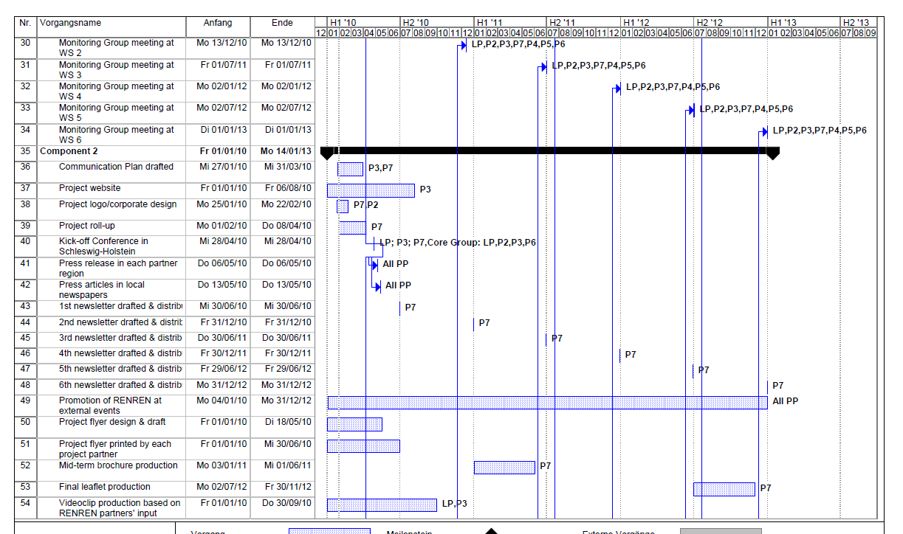
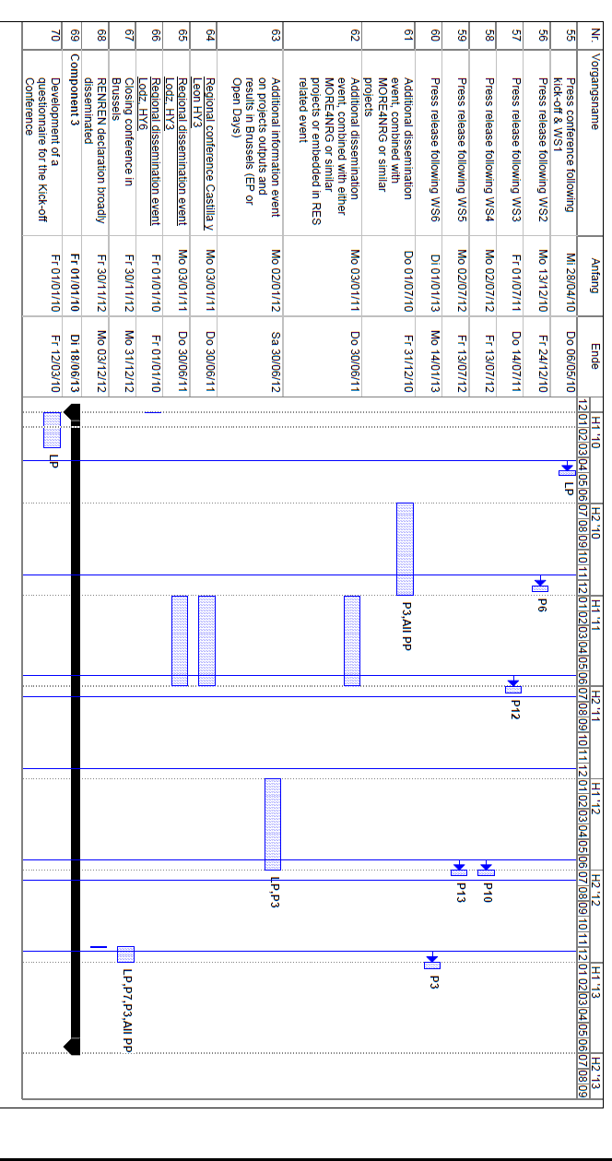

Annex 2
The following list provides some of the most distinctive specialised media and organisations, which could be contacted:
European Union:
• Agence Europe
• Euobserver
• Euractiv
• EIS (Europe Information Service)
• Aquí Europa
• Eupolitix
• Eurobusiness
• Euro-correspondent
• European Voice
• New Europe
• FEDARENE: European Federation of regions by the Environmental and Renewable Energy

Environment:
• Earthscan Journals
• Edie
• ENDS Environment Daily
• Energy Efficiency News
• Eurosolar
• Green Facts
• Environment Watch: Europe
• Ambienta
• Ambientum
• Nature
• Residuos
• Renewable Energy Focus
• Renewable Energy Journal
• Science Daily
• Sustainable Business
• World Water & Environmental Engineering
• Water & Waste Treatment
• Local Authority Waste & Environment
• Journal of Residuals Science & Technology
• The Ecotimes
• Redcicla
• Environmental Energy Agency
• European Energy Agency
• Bioenergy, magazine
• Energias renovables, magazine

Research and Innovation:
• RTD Info, the Research Magazine of the European Commission
• Empresa e Innovación. Actualidad Europea
• Cordis Express
• Advances in Environmental Research

Associations and federations:
• WindComm (Schleswig-Holstein Wind Community)
• Offshoe foundation Varel/Germany
• AEBIOM (European Biomass Association)
• EGEC (European Geothermal Energy Council)
• EPIA (European Photovoltaic Industry Association)
• EREF (European Renewable Energies Federation)
• ESHA (European Small Hydropower Association)
• ESTELA (European Solar Thermal Electricity Association)
• ESTIF (European Solar Thermal Industry Federation)
• EUBIA (European Biomass Industry Association)
• EU-OEA (European Ocean Energy Association)
• EUREC Agency (European Association of Renewable Energy Research Centres)
• EWEA (European Wind Energy Association)

Other networks:
• More4NRG (Lead partner Flevoland/Netherlands)
• Fedarene
• REN21
• LoCare (Lead partner South Denmark/Denmark)

