ChemMultimodal
Promotion of Multimodal Transport in Chemical Logistics

Working Group Meeting, Steering Group Meeting
Dissemination Conference
18-20 April 2017

Usti nad Labem, CZ

Venue:
Krajský úřad Ústeckého kraje
Velká Hradební 3118/48, 400 02 Ústí nad Labem

Clarion Congress Hotel Ústí nad Labem****
Špitálské náměstí 3517, 400 01 Ústí nad Labem, Česká republika

Agenda

18 April – Tuesday

16:00 - 18:30 Working Group Meeting, Krajský úřad Ústeckého kraje
- Progress of project work
- WP1 Information on Organisation and Management
- WP6 Information on Dissemination and Communication
- Review to 1st Progress Report. Preparation of 2nd Report

19:00 Accommodations and Dinner, Clarion Congress Hotel Ustí nad Labem
(Requirements reserving rooms under the motto “Project ChemMultimodal - Usti the regional conference”, please send an email: fom.cchu@clarion-hotels.cz, Miss Dana Kubíčková.)

19 April – Wednesday - Clarion Congress Hotel Usti nad Labem

9:30 – Attendance

10:00 – 15:00 Dissemination Conference

- 10:00 – 10:45 Foreword governor, Introduction of the project – Lead Partner, Word representative of the Usti Region and Svaz chemického průmyslu ČR

- 10:45 -11:00 Coffe break, Press conference

- 11:00 – 12:15 Best practise to promote MM, Companies presenting best practise

- Metrans, a.s. Praha, Jaroslav Fuert, http://www.metrans.eu/
- Bohemiakombi spol. s.r.o., Praha Vladimír Fišer, ředitel, http://bohemiakombi.cz/
- AWT a.s. Ostrava, bude upřesněn, http://www.awt.eu/cs
- ČESMAD BOHEMIA, Sdružení automobilových dopravců, Vojtěch Hromíř, generální tajemník, http://www.prodopravce.cz
- ŽESNAD.CZ, Sdružení železničních nákladních dopravců ČR, Oldřich Sládek, výkonný ředitel
- Unipetrol RPA, s.r.o., it will be specified, www.unipetrol.cz
- Ewals Cargo Care, Česká republika, it will be specified, www.ewals.com/cz/

12:15 – 13:00 Lunch

13:00 – 15:00 Identifying Potential for Modal Shift, LSP presenting strategies for development of new regular connections

15.00 – 16.00 Discussion, Coffee Break

16:00 – 19:30 Working Group Meeting

- 17:00 – 18:30 Presentation of Project Partners
Presentation of partners on tool development (see ppt template, 10 min each country – share presentation in case of more partners per country)

Implementation of WP2 Analysis and Tool Development
- Discussion about finalisation of of Tool Development
- Preparation and Timing of next IWG meeting
- Agreement on next steps for implementation of project activities

18.30 – 19.30 Steering Group Meeting

20.00 Dinner - The restaurant Na Rychtě, Kláštěrní 75/9, Ústí nad Labem, 400 01
http://www.pivovarnarychte.cz/cz/hlavni-strana.html

20 April – Thursday

9:00 – 11:00 Site visit - Transportation to the port Labe

11:00 – 12:00 Lunch, Clarion Congress Hotel Ústí nad Labem

12:00 - Departures

Registration

Please register with the help of Google Form Link until 3rd April
google link will be updated by LP

Hotel Recommendation
Clarion Congress Hotel Ústí nad Labem****
Špitálské náměstí 3517
400 01 Ústí nad Labem, Česká republika

The term is open 22 single rooms.

Please book your room individually. Provide information that secured advance booking Usti Region.
http://www.clarioncongresshotelustinadlabem.com/cs/

Travel
The international airport Vaclav Havel in Prague
From airport to the train station take bus Airport Express. TERMINÁL 1 - HLAVNÍ NÁDRAŽÍ.
http://www.dpp.cz/linka-ae-airport-express/
From airport to Usti nad Labem train is coming. http://jizdnirady.idnes.cz/vlakyautobusy/spojeni/ Tickets can be purchased at the train station.

From train station Ústí n.L.hl.n. is 12 minute walk to Clarion Congress Hotel. (see map below)

From the airport, we can arrange transport by car. Please report on the number of people arriving at the airport Vaclav Havel in Prague. Leaving Prague at 2 pm.

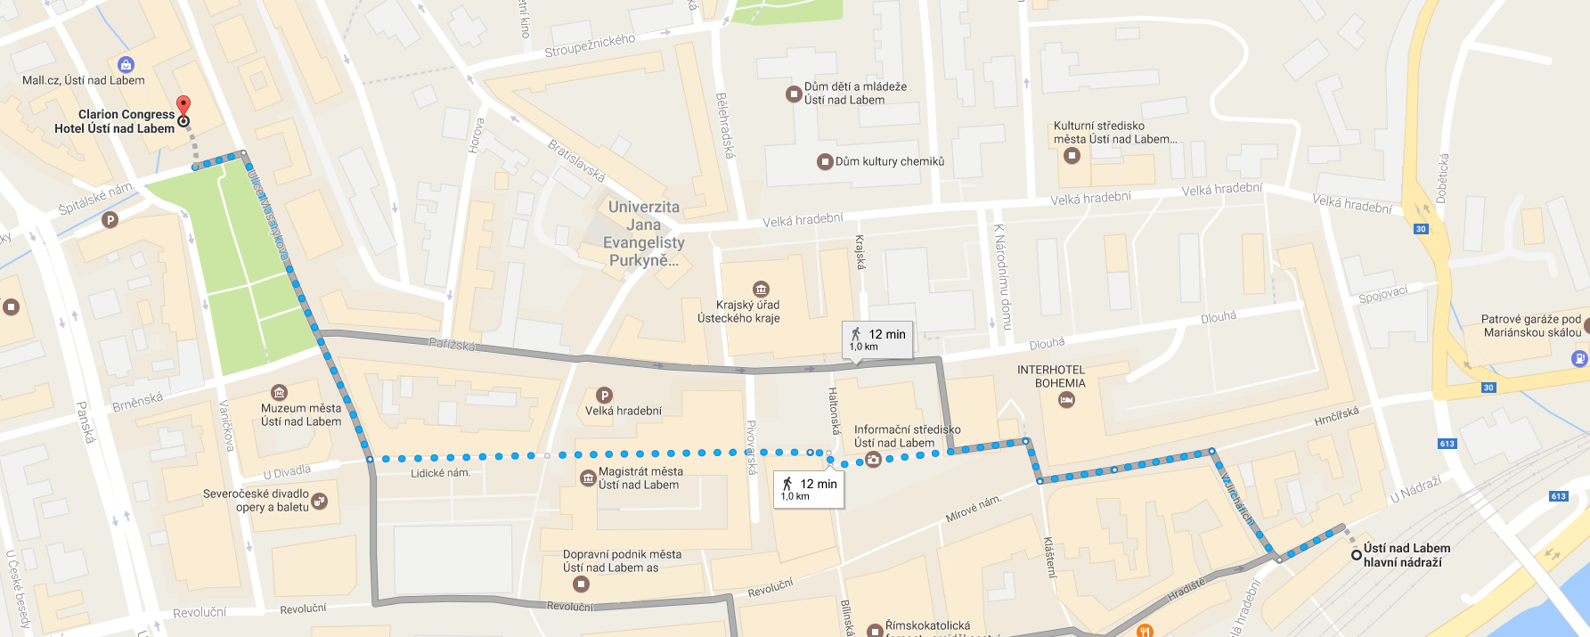

Contact
Ing. Ivana Poláková, e-mail: polakova58@gmail.com, tel.: +420 603 183 081
Ing. Martina Sedláková, e-mail: sedlakova.m@kr-ustecky.cz

