Extract / Summary for project RENREN
Introduction - Analysis – Diagnosis and Measures
BIOMASS ACTION PLAN
FOR CASTILLA Y LEÓN - PBCyL
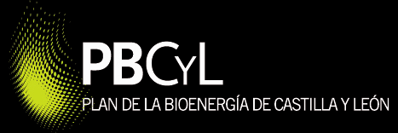

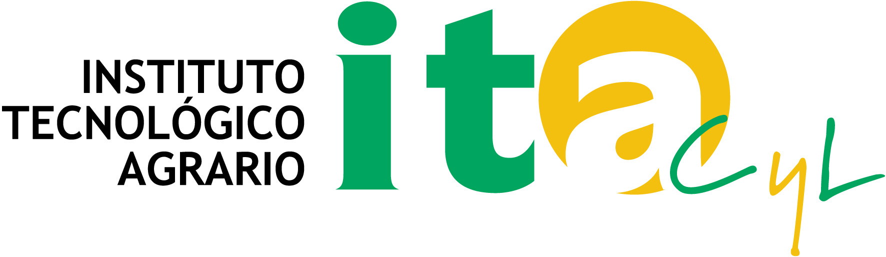
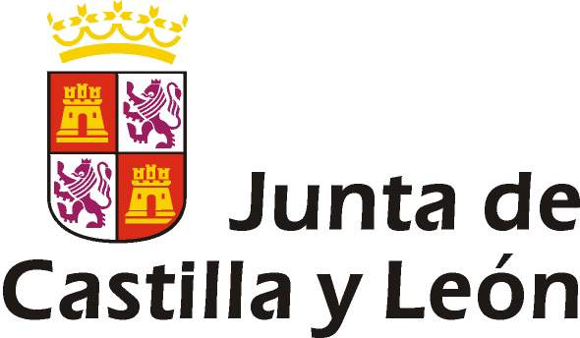
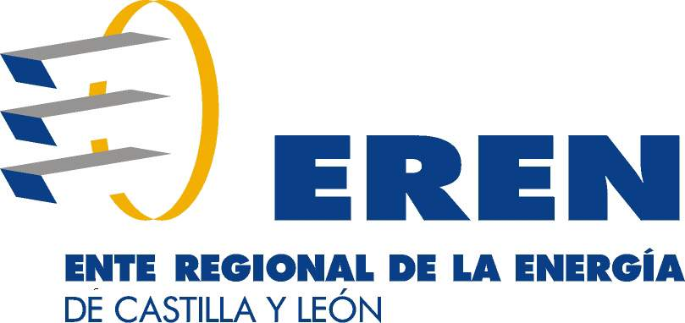

1.- INTRODUCTION

1.1.- PBCyL - BASIC DESCRIPTION, MAIN ASPECTS AND METHODOLOGY.
The proposal of Biomass Action Plan (BAP) for Castilla y León is based in the specific work developed by a multidisciplinary group of the regional government of Castilla y León (Spain) in biomass planning during more than two years.
The ideas expressed in the European BAP Driver project have also been considered.
MAIN ASPECTS.
Castilla y León BAP proposal has specific key - issues that, in some way, conform it.
A) A Plan aimed at Measures.
The development of a BAP for Castilla y León depends on the integration of three factors:
1. The decision about what you really want.
2. The specific nature of the biomass sectors.
3. The normal structure of a Plan (Analysis - Objectives - Measures - Results evaluation - Control and monitoring).
From this approach, the question of what you want will turn into what you do and the “foundation stone” of this BAP will be their measures, that is to say, their specific developing activities.
In this way, an adequate definition of development actions will be the main part of the Plan, and the whole text will be drawn up and thought around this item. So, practical aspects of the Plan are considered to be more important than the theoretical such as the analysis or long term targets statement.
Obviously, the definition of measures will be founded on reality: potential energy demand, targets, etc., but once the objectives have been stated, an inadequate definition of measures only produce deceived expectative, mistrust and demoralization. All of them constitute self-defeating effects.
B) Supply and Demand.
In the analysis, it is taken into consideration the geographical limits of actuation of the Plan (the region of Castilla y León) and it is made a specific analysis for supply and another one for demand.
In this way, BAP has counted the possibilities of regional sectors that could supply different resources: forest, agriculture, livestock, etc. and also, the whole energy demand has been considered.
In some areas, regions or nations there will be deficit in some or all type of resources and in others could appear a surplus.
Considering that there is no problem to install an Austrian boiler in Spain or a British turbine in Germany, we should internalize the same concept about biomass or biofuels.
C) The Subsector concept.
In a general view, the statistic potential to use different materials, technologies, kinds of outputs or system sizes offers a huge number of energy scheme possibilities.
However, between this wide range of combinations, it is easy to find a short number of possibilities which present homogeneous characteristics of market - management concepts, technologies, sizes, uses and biomass types. These possibilities are understood as subsectors.
In this way, a suitable analysis will be done around the following subsectors:
- Domestic heat.  - District heating grids.  - Industrial heating.  - Large power plants. | - Small - medium power plants.  - Biofuels production.  - Transport consumption.

D) The Value Chain.
The biomass research will be based on different subsectors. They are conceived around their applicable value chain, so that if one of their links is broken, the whole chain will break.
The systematic analysis and “bottle necks” characterization of the different value chains of biomass subsectors have allowed defining principal aspects about measures.
These “bottle necks” will be different for each country or region, economic or market situation, so the results of the analysis of value chains could vary from one case to another.
PROPOSAL OF METHODOLOGY - CONTENTS.
This figure shows a general vision of PBCyL methodology.

Offer analysis.
Resources

Demand analysis.
Applications
REALITY AND PERSPECTIVES
OBJECTIVES
Quantitative
Qualitative

Identify problems and opportunities
Global effects
Assessment
Specific effects
Assessment

CONTROL
SYSTEMS
Synthesis
Diagnostic
Contexts

MEASURE GENERATION AND DEFINITION

MEASURE
IMPLEMENTATION

As it has been mentioned before, in a multisubsector market in which the final objectives are boost and structured, the whole planning works will go around the triangle: measures - implementation - control.
Obviously, these concepts will be founded over an adequate statement of long term objectives and in a honest evaluation of reality and perspectives but, like in a long countryside walk, the most important part are the firsts steps.
Therefore, the planning work proposal will begin with the diagnosis of the sector that offers their reality and perspectives. This diagnosis should integrate three big items that will give data and requirements:
- The offer analysis: available (current and future) biomass.
- The demand analysis: technologies, applications and potential bioenergy demand.
- Context: global items about economy, legislation, environment, forestry and agrarian aspects, etc.
In the diagnosis, these items are integrated to give a general vision that will offer special key elements for the sector. In the same way, it discovers global standards and around them, the biomass market is configured (the so called subsectors) and they are used to make specific analysis.

Once the analysis of the current situation and perspectives for bioenergy have been established, the objectives must be set from two points of view:
- Qualitative view states principles such as maximizing rural development or competitiveness among biomass companies. In the same way, this view introduces some priority criteria.
- Quantitative view states two kinds of objectives for 2013 and 2020 scenarios:
  - Objectives of supply in the amount of biomass (tons) offered to the bioenergy market in their different types (agriculture or forestry residues, energy crops, etc.).
  - Objectives of use in the amount of bioenergy (toes) consumed in their different types (electricity, thermal energy or transport).
To state a quantitative objective is as important as the evaluation of the effects. So an objective to boost a determine quantity of forestry residues means specific figures of investments, costs, incomes, loans, amount of employments and typology of jobs, CO₂ tons not emitted, ratios of energy dependence, etc.
The next step would be the comparison between objectives, reality and perspectives. This step results in the binome problem (or opportunity) - measure, which would be of three different kinds:
- Specific problems - measures to boost the production of different biomass.
- The study of the problems – measures in each subsector.
For this study, the systematic following of the value chain in both directions of each subsector would be the best tool to find the opportunity - problems and to define measures.
- Vertebration problem - measures about education, administration, communication, etc.
Each measure will have specific effects. The direct (investment subsidized, environmental impact avoided, etc.) or indirect effects will match the effects of objectives. In this way, the contribution of each measure to the general objectives and effects would be defined.
Obviously the measure specific effect analysis will offer the importance of each one and combined with the short - medium feasibility would configure a program of “urgent measures”.
To state objectives and measures, is as important as stating the procedures in which these will be controlled, as well as the coercive influence of the created tools.
These procedures will compare the results with those established in the Plan, and will include a specific process to define new measures and objectives not previously foreseen in it.

1.2.- PBCyL INDEX - MAIN DOCUMENT AND APPENDICES.
INDEX OF MAIN DOCUMENT:

CHAPTER 1.- INTRODUCTION AND SUPPORT:
1.1.- Introduction.
1.2.- Supporting issues for a Biomass Action Plan for Castilla y León.
1.3.- Planning approaches for bioenergy in other competences. Some policies and planning tools affecting bioenergy.
CHAPTER 2.- ENERGY CONTEXT:
2.1.- Introduction and synthesis.
2.2.- World energy context.
2.3.- International perspective of bioenergy.
2.4.- EU energy context.
2.5.- National energy context.
2.6.- Situation of energy in Castilla y León.
CHAPTER 3.- THE SUPPLY ANALYSIS – BIOMASS RESOURCES:
3.1.- General aspects for biomass analysis.
3.2.- Forestry residues.
3.3.- Energy crops.
3.4.- Agriculture residues.
3.5.- Livestock residues.
3.6.- Wastes from food and agriculture processing industries and animal by-products.
3.7.- Forest industries biomass.
3.8.- Urban and industrial biomass
3.9.- Synthesis of potential production of resources and available potential in Castilla y León.
CHAPTER 4.- THE DEMAND ANALYSIS – ENERGY APPLICATIONS:
4.1.- Introduction.
4.2.- Biofuels production.
4.3.- Electrical Applications.
4.4.- Thermal Applications.
4.5.- Applications in transport..
4.6.- Synthesis of bioenergy applications en Castilla y León.
CHAPTER 5.- SECTOR DIAGNOSIS:
5.1.- Introduction.
5.2.- Flow Charts / Diagrams.
5.3.- Diagnosis of current situation.
5.4.- Overall assessment and a draft of forecasts.
CHAPTER 6.- GOVERNING PRINCIPLES AND PRIORITIES:
6.1.- Introduction.
6.2.- Governing principles.
6.3.- Best Priorities.
CHAPTER 7.- SETTING QUANTITATIVE OBJECTIVES – TARGETS:
7.1.- Introduction.
7.2.- Methodology for setting objectives.
7.3.- Targets for supply of biomass.
7.4.- Targets for demand of bioenergy.
CHAPTER 8.- MEASURES AND ACTIONS:
8.1.- Introduction.
8.2.- Programmes and courses of action.
8.3.- Measures and actions.
8.4.- Summary of priority measures and actions.
CHAPTER 9.- ECONOMIC ASPECTS:
9.1.- Introduction and methodology.
9.2.- Economic aspects related to supply.
9.3.- Economic aspects related to demand.
9.4.- Other economic aspects.
9.5.- Summary.
CHAPTER 10.- EFFECTS:
10.1.- Introduction and methodology.
10.2.- Summary of effects.

Materials: energy crops, forestry residues, landfills, etc.; Technologies: gasification, burning, steam cycle, etc.; Outputs: electricity, heat or transport; Sizes: from a 1.000 € stove to a 100.000.000 € power plant.

