INTERNATIONAL AGRICULTURAL COOPERATION
Chinese delegation from province of Anhui visited the Ustí Region

Krajský úřad Ústeckého kraje,
Velká Hradební 3118/48,
405 02, Ústí nad Labem

Telefon: +420 475 657 111
Fax: +420 475 200 245
E-mail: urad@kr-ustecky.cz

Ústí nad Labem, 14. 8. 2012

The delegation from the Chinese province of Anhui visited the Ustí Region on 1. – 2. 8.th 2012. The main representative of the rare delegation was Assistant Governor, Mr. Shao (functions of Deputy Presidend for Agriculture). The development in agriculture has been succesfully negotiated.

„I´m glad it appears that our partnership is not only formal, but fills in a particular area, which is agriculture. I believe that the Ustí Region has something to offer. This is evidenced by our farmers who bring a clear vision for future cooperation in the field of fruit growing, cattle breeding and growing of oilseed rape and wheat,“ said Mr. Arno Fišera at the beginning of the meeting.

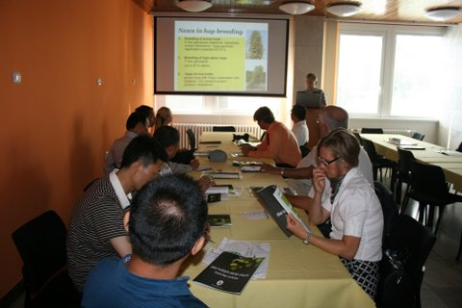

Presentation of the Managing Director Ing. Jiří Kořen, PhD. from Hop
Reserch Institut
Deputy Governor, Mr. Arno Fišera officially welcomed the Chinese delegation in the Ústí nad Labem. After the start of the meeting he presented the agriculture of Ustí Region. The presentation of the Chairman of the Regional Chamber of Agriculture Ustí Region Mr. František Loudát continued, CEO of Sempra a. s. Mr. Potůček and Mr. Kudla from the family farm of Šluknov and representatives of companies Agrokomplex Verneřice or Agrocom Hrušovany.

In informal discussions Czech delegation met with interesting details of Chinese rural life and view of the current agriculture standard. An extensive development of Chinese agriculture and society was clarified by the Chinese representatives. Representatives of the Chinese delegation invited Czech members to the agricultural exhibition in Hefei focused on central and eastern Europe, which takes place on the 7th - 9th 2012, in order to get knowledge in facts.

The first day of the visit the Chinese delegation visited an agricultural producer Straškov Astur, where they were greeted with traditional bread and salt. Followed by the tour of mechanization, harvesting grain, livestock and biogas plant in Račiněves.

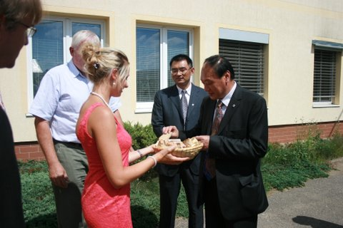

Traditional welcome of Mr. Shao in Astur Straškov farm.

The last part of the first day program was Žernoseky cellars winery associated with wine tasting. The next day the delegation visited the city Žatec and there Hop Researche Institute, Hop museum and Temple of hops and beer, including the tower. The whole day was devoted to the traditional production of beer and it’s cultivation and history.

Žernoseky Winery including tours of the cellars with oak functional barrels

Chinese delegation was interested in all information and examples of agricultural practices. Local farmers have expressed interest also, such as an information exchange of new varieties of pears growing and cattle breeding as well as an experience of intensive cultivation of wheat and rapeseed.

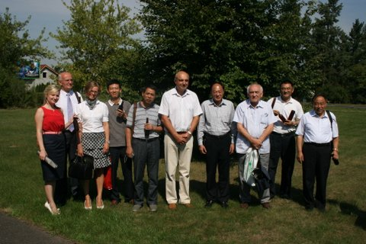

Representatives of Czech-Chinese delegation headed by Petr Husák and
Ing. Monika Zeman

The purpose of the visit was familiarization with the local agricultural production and the subsequent creation of active cooperation with local farmers. "Thanks to cooperation will rise up a platform for electronic communication and data information sharing in the field of agriculture between the Chinese provinces of Anhui and Ústecký region. The aim of this platform is a technological and information development of agriculture, " said County councilor Peter Husak.

First contact with the province of Anhui has been made already in 2007. At the end of November of that year the delegation from the Ústí nad Labem visited the province of Anhui. They opened the discussion of cooperation between this two regions. The contract of cooperation between Ústí Region and this province was signed in 2009. That same year the Chinese delegation visited the Ústí Region, where met with the mining industry, the use of solar power plants, industrial zone Triangle, and CzechInvest.

Anhui Province is located in the south-eastern part of China, with more than 67 million inhabitants and has favorable conditions for the development of agricultural production. Most of the agricultural land is fertile, rainfall and warm climate are other factors boosting the potential development of this important sector. The main crop products are rice, wheat, soy, corn and sweet potatoes. Significant is also the growing economic modes of production, such as rapeseed, tobacco, tea, jute, cotton, etc.

The province is also rich in energy and other raw material sources and treated, where the most important coal and the subsequent production of steel and metallurgical materials. Anhui also lag in the production of light industry, which dominates the production of home electronics. Last but not least, Anhui province is becoming known center of tourism. On its territory is located 5 mountain national parks and 3 national cultural center. Some monuments are protected by UNESCO (Mount Huangshan or Yellow Mountain).

